**Lab 5 Configuring Printing and Managing Data Storage**

**Task 3 – Activity**

**(Save your work because your answers may be required to provide in the Mid-Semester and Final Examination.)**

# Activity 5-1 Installing the Print and Document Services Role

**Time Required**: Approximately 15 minutes

**Objective**: Install the Print and Document Services Role.

**Description**: In this activity, you install the Internet Printing Client in Windows Server 2016 so that it can communicate using IPP, and install the Print and Document Services role along with the Print Server role service.

**Requirements**: Take screenshots on Step 7, 14, and 21, and answer questions 22

and 23.

1. Open Server Manager, if necessary.
2. Click Manage and click Add Roles and Features.
3. If you see the Before you begin window, click Next.
4. Ensure Role-based or feature-based installation is selected and click Next.
5. Be sure your server is selected in the Select destination server window and click Next.
6. Click Next in the Select server roles window.
7. Click Internet Printing client in the Select features window and click Next.

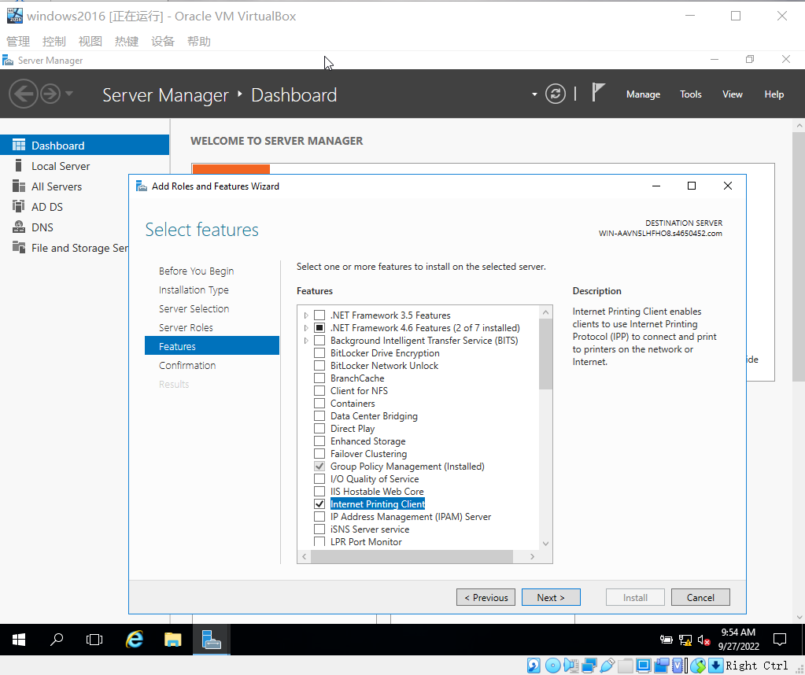

Figure 1.1 Add Internet Printing client.

1. Click Install in the Confirm installation selections window.
2. Click Close.
3. Click Manage and click Add Roles and Features.
4. If you see the Before you begin window, click Next.
5. Ensure Role-based or feature-based installation is selected and click Next.
6. Be sure your server is selected in the Select destination server window and click Next.
7. In the Select server roles window, check the box for Print and Document Services. If you see a dialog box to add features required for a role, such as remote server administration tools, click Add Features.

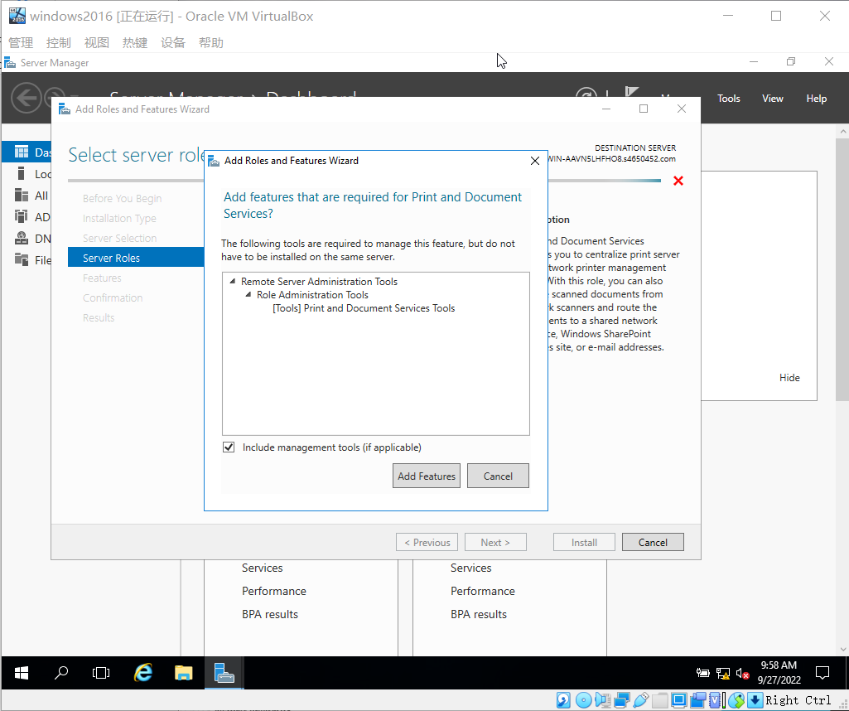

Figure 1.2 Add Features Required for a Role.

1. Click Next in the Select server roles window.
2. Click Next in the Select features window.
3. In the Print and Document Services window, read the information about the Print and Document Services role and note that there is a link to learn about this role. Click

Next.

1. In the Select role services window, make sure Print Server is selected (the default), and click Next.
2. Click Tools and click Print Management.
3. In the left pane, click the right-pointing arrow in front of Print Servers to view the available print services, including your server.
4. Right-click your server, such as ‘EC2AMAZ-Q9OQD3(local)’ if you use AWS server and click Properties.

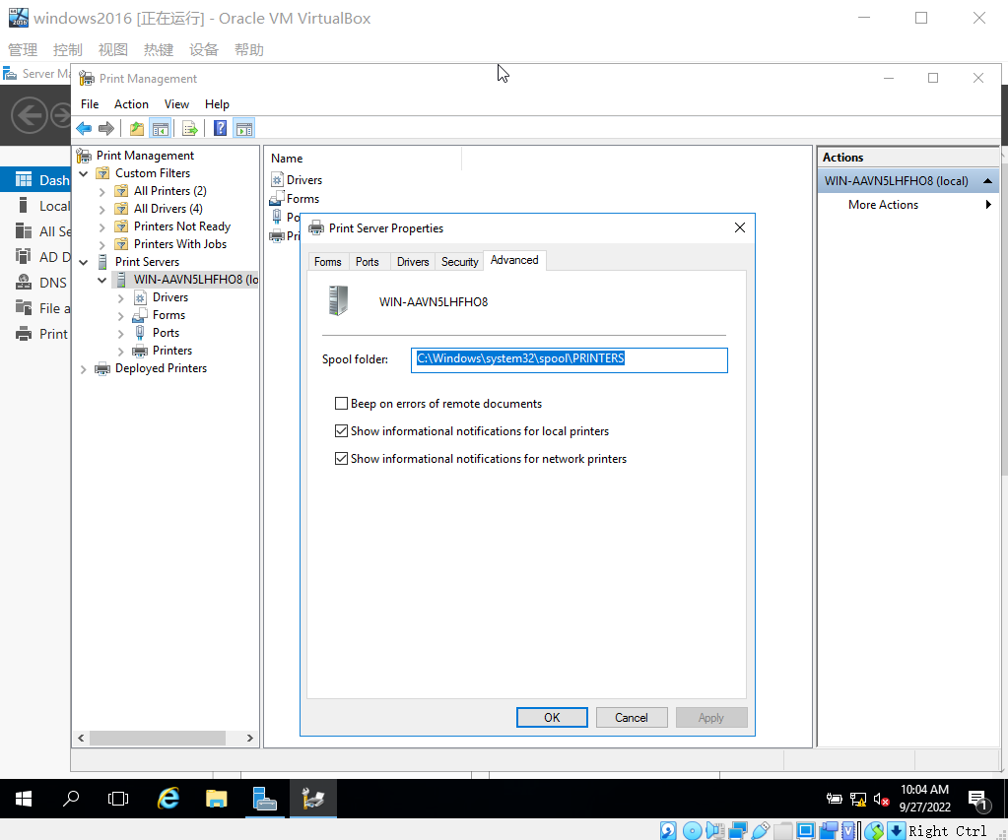

Figure 1.3 Click Properties of Your Server

1. Five tabs are shown in the Print Server Properties dialog box: Forms, Ports, Drivers, Security, and Advanced. Click each tab to view its configuration options. If it is not selected, click the Advanced tab.

* What spooler management options are already selected? What is the folder and its path where spooler files can be written?

Answer One: Show informational notifications for local printers.

Show informational notifications for network printers.

Answer Two: C:\Windows\system32\spool\PRINTERS

1. Click the Security tab. Notice the groups and users who have security access.

* What default permissions are granted to the Everyone group (you’ll learn more about permissions in the section, Configuring Security).

1. Click Cancel.

# Activity 5-2 Installing a Printer

**Time Required**: Approximately 15 minutes

**Objective**: Install a printer using the Network Printer Installation Wizard, and learn how to enable printer publishing in the domain’s Group Policy.

**Description**: In this activity, you install a printer using the Network Printer Installation Wizard. This activity does not require a printer to be attached to the computer, because you practice a manual configuration without automatic detection. Publishing a printer for domain-wide access must be enabled in a domain’s Group Policy within Active Directory. In this activity, you make certain that the domain’s Group Policy for publishing printers is enabled.

**Requirements**: Take screenshots on Step 3, 9, 13, 18, 21, 29, and answer questions on

Step 5, 15 and 24.

1. Open the Print Management window, if it is not already open. Or, to open it from Server Manager, click Tools and click Print Management.
2. In the left pane, use the right-pointing arrow, if necessary to ensure you can view the

server name under Print Servers.

1. In the left pane, right-click the server name under Print Servers and click Add Printer.

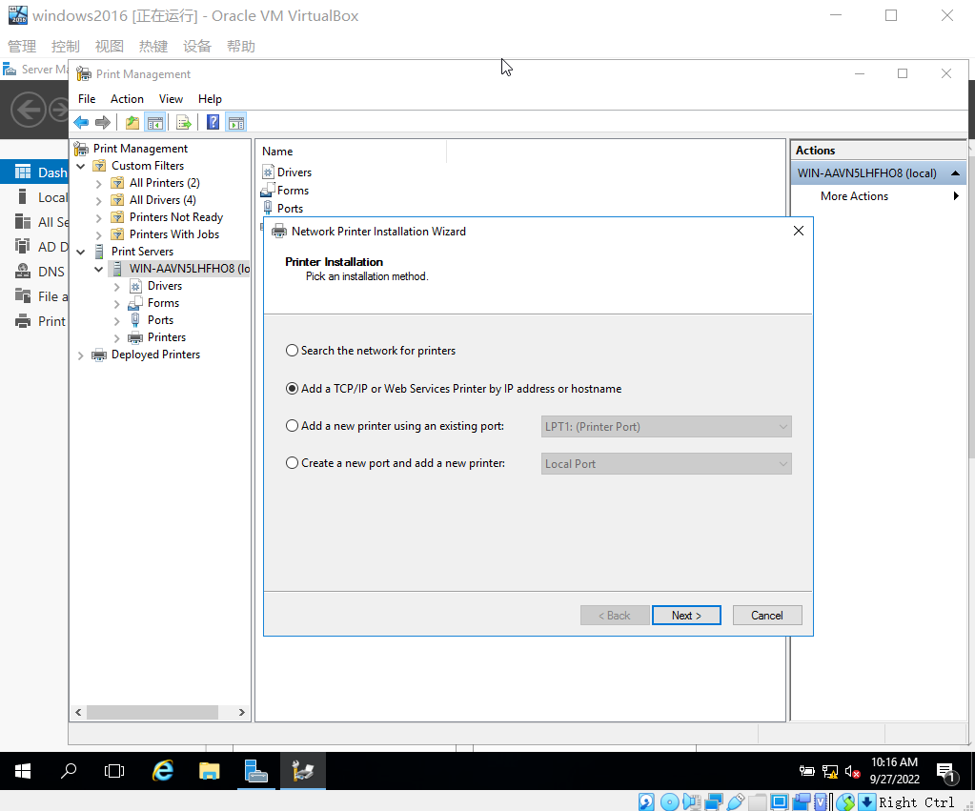

Figure 2.1 Add Printer.

1. Notice the options to install a local or a network printer. A local printer is one that is physically attached to the computer through a port, and a network printer is one that is connected to a different computer or to a dedicated print server device (wireless or cabled to the network) and that is shared over the network. For this activity, click Add a new printer using an existing port.
2. Click the down arrow that shows LPT1: (Printer Port) as the default.
   * What options are available?
   1. LPT1:(Printer Port)
   2. LPT2:(Printer Port)
   3. LPT3:(Printer Port)
   4. COM1:(Serial Port)
   5. COM2:(Serial Port)
   6. COM3:(Serial Port)
   7. COM4:(Serial Port)
   8. FILE:(Print to File)
   9. PORTPROMPT:(Local Port)
3. For practice, use the default selection for the printer port (port to which the printer is connected), such as LPT1: (Printer Port), and click Next.
4. Ensure that Install a new driver is selected and click Next.
5. For the Manufacturer, select Brother (the default), and for the Printer, select Brother Color Leg Type 1 Class Driver (or select a manufacturer and printer of your choice). If you selected the defaults, notice that the driver is digitally signed. Digital signing offers some security that the driver is authentically written by the manufacturer. Click Next.
6. In the Printer Name and Sharing Settings dialog box, ensure that there is a check in the box for Share this printer, which is the default. In the Share Name text box, enter Office Printer plus your initials, such as Office Printer JR. This is the name that users on the network will see. In the Location text box, enter a theoretical room number, such as Room 10. Also, enter a comment, such as Shared color printer. Click Next.

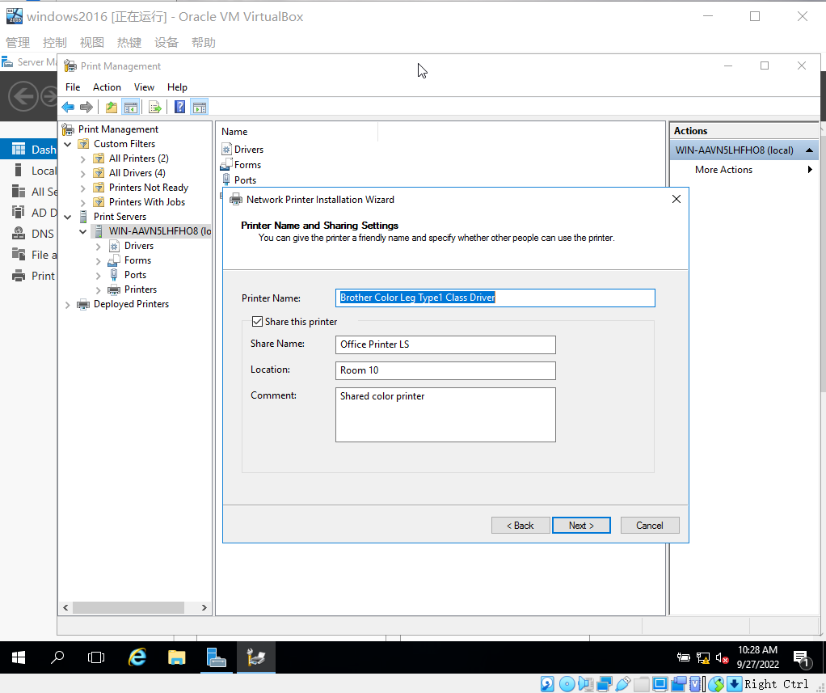

Figure 2.2 Printer Name and Sharing Settings

1. Review the information for the printer and click Next.
2. Ensure that the Status shows the driver and printer installations succeeded. Notice that you could now print a test page as a way to test your installation. You can also choose to add another printer. Click Finish.
3. Ensure the Print Management tool is open.
4. In the left pane, use the right-pointing arrow to expand the elements under the print server so that you see Printers listed. Click Printers in the left pane to view the installed printers in the middle pane.

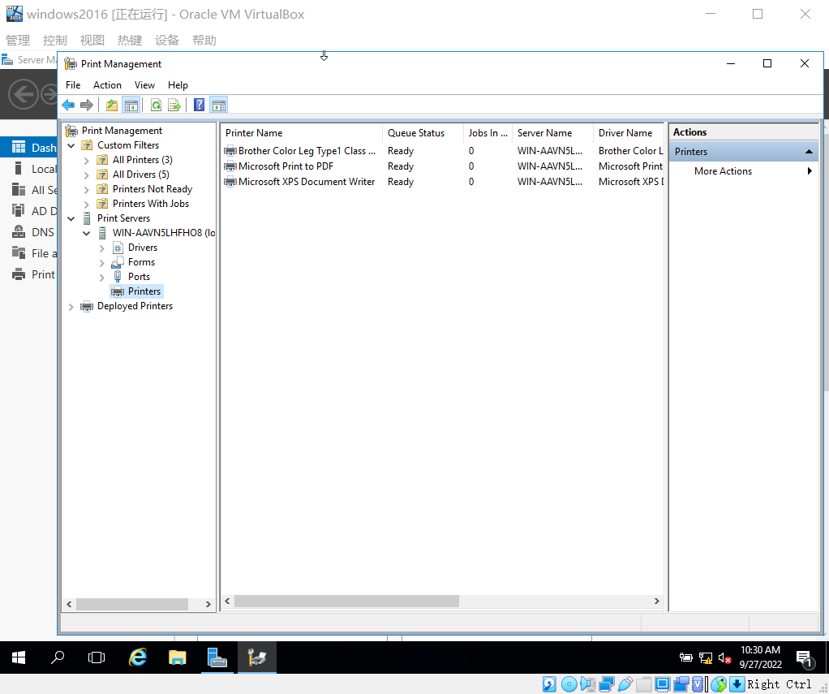

Figure 2.3 View the Installed Printers

1. In the middle pane, right-click the printer you installed, such as Brother Color Leg Type 1 Class Driver. Click Properties.
2. Make sure the General tab is displayed. Click the Preferences button near the bottom of the dialog box.

* What tabs are shown? What are the options on the tabs that can be configured?

Answer One: Layout, Paper/Quality

Answer Two: Portrait, Landscape

1. Click Cancel.
2. Click Tools and click Group Policy Management.
3. In the left pane, use the right-pointing arrows to expand Domains and your specific domain, so that you see Default Domain Policy.
4. Right-click Default Domain Policy and click Edit.
5. In the left pane of the Group Policy Management Editor window, as necessary, use the right-pointing arrows to display the elements under these folders: Computer Configuration, Policies, and Administrative Templates.
6. In the left pane, click the Printers folder under Administrative Templates.

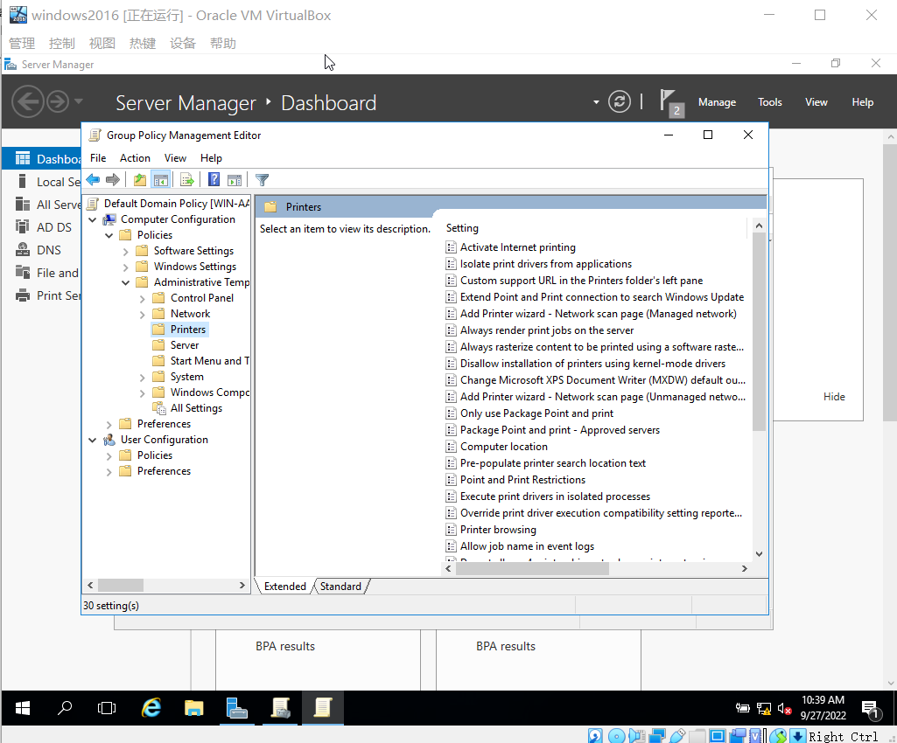

Figure 2.5 Click the Printers folder.

1. If necessary, click the Standard tab at the bottom of the middle pane for better viewing of the settings that can be configured.
2. Scroll through the right pane and notice the policies that can be configured.
3. In the right pane, double-click Allow printers to be published.

* How is this policy currently configured?

Answer: Not Configured.

1. Make sure Enabled is selected.
2. Click OK.
3. In addition to enabling printer publishing, you might want to enable the ability for browsing master servers to include published printers, as users browse for network printers when installing them through their operating system’s version of the Network Printer Installation Wizard. To enable printer browsing, double-click Printer browsing, select Enabled (if it is not already selected), and click OK.
4. Review the middle pane of the Group Policy Management Editor window to ensure your changes have been made.
5. Close the Group Policy Management Editor window. Close the Group Policy Management window.

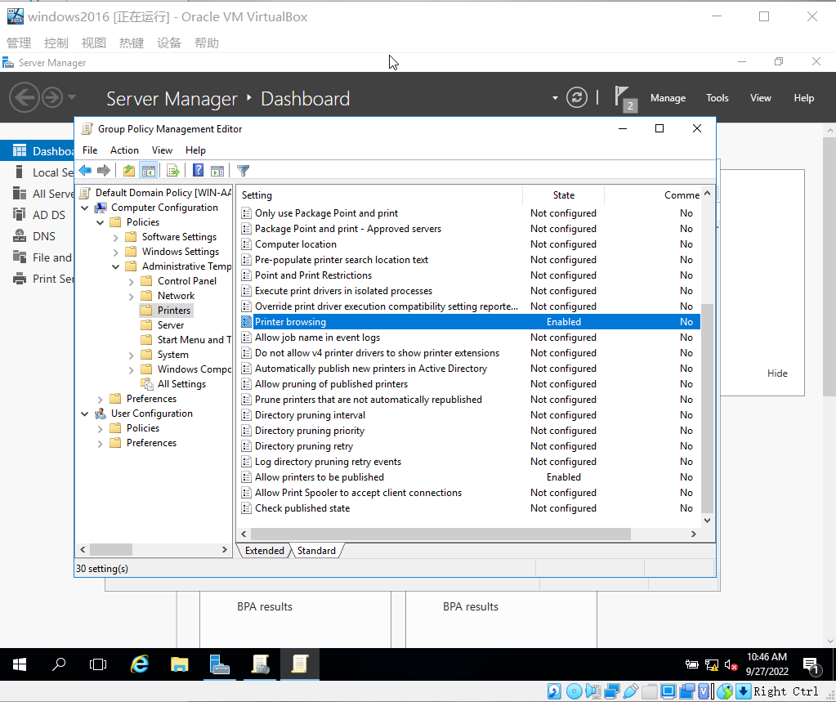

Figure 2.6 Review the middle pane of the Group Policy Management Editor window.

# Activity 5-3 Creating a Simple Volume and Managing Disk

**Time Required**: Approximately 20-30 minutes

**Objective**: Create a new partition from unpartitioned disk space.

**Description**: This activity enables you to create a new partition. You’ll need access to a server that has some amount of unpartitioned disk space or free space. If a server is not available with unpartitioned space, remember the location of this activity so you can refer to these steps before partitioning disk space in a live work situation.

**Requirements**: Take screenshots on Step 2, 4, 7, 10, and 15.

1. Create a volume if you use windows server 2016 on AWS EC2; then attach this

volume to your instance as unallocated disk space (Disk 1). Right-Click Disk 1, Click Online; Right-Click Disk 1 again, Click initialization. (You can watch Youtube video [https://[www.youtube.com/watch?v=idnRRt3RMGM](http://www.youtube.com/watch?v=idnRRt3RMGM)] that guides you how to install volume). **Note that, after complete this activity, please delete your created volume; otherwise it may cost your credits.**

1. Open Server Manager. Click Tools. Click Computer Management. Under Storage, Click Disk Management.
2. Right-click the unallocated space created on Step 0 (such as Disk 1), and click New Simple Volume. If you don’t use AWS EC2 (using vSphere), and you can use free space if there is no unallocated disk space.

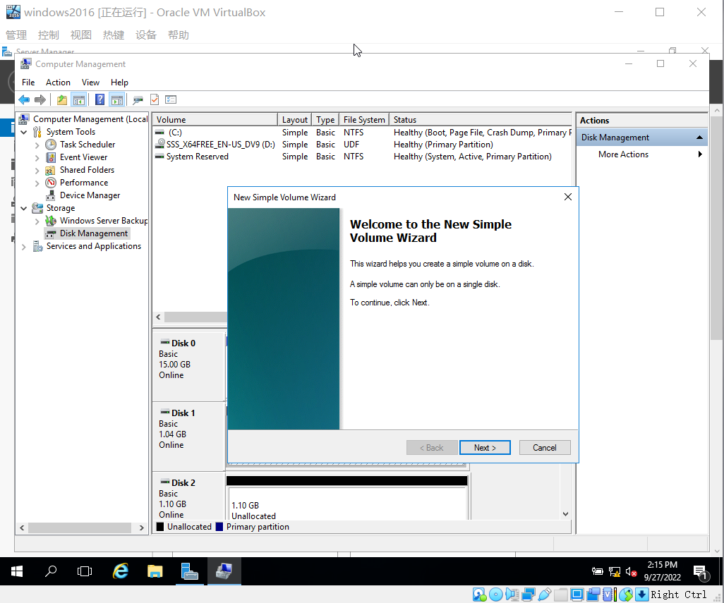

Figure 3.1 Use Free Space If There is no Unallocated Disk Space.

1. Click Next in the New Simple Volume Wizard.
2. For Simple volume size in MB, enter an appropriate size for the volume you are creating or use the default entry.

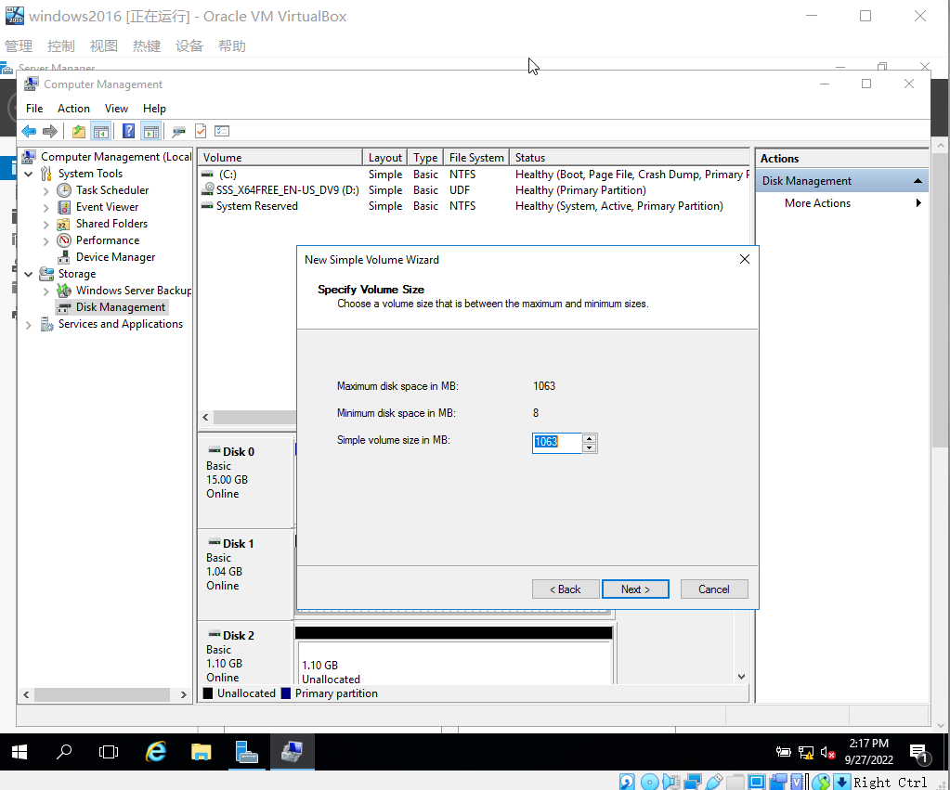

Figure 3.2 Enter an Appropriate Size for the Volume

1. Click Next.
2. Use the default drive letter, such as D, and click Next. (If you see a message that the drive letter is already mapped, change the current mapping or go back and select a different drive letter.)
3. In the Format Partition dialog box, the default is to format the volume using NTFS and use the Default allocation unit size. You can also specify a volume label. Additionally, you have the option to perform a quick format, which is not advised because this doesn’t check the integrity of the partition. Another option is to compress folders and files by default. Click Next.

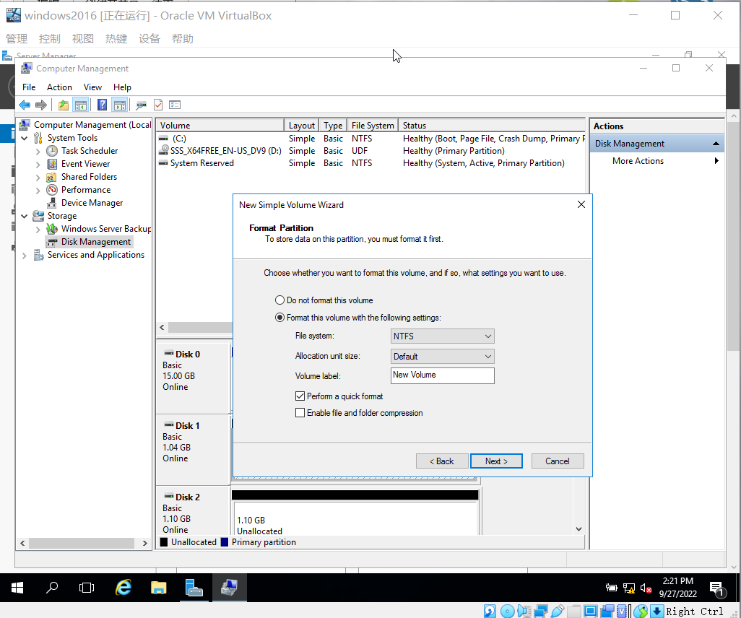

Figure 3.3 Format Partition dialog box.

1. Review the selections you have made and click Finish. (It may take a few minutes to create the new simple volume. The Disk Management tool displays its progress, such as formatting as it is working.)
2. Right-click the new disk you create on Step 0.
3. Make sure that the correct disk is selected, such as Disk 0 or Disk 1 (check all that apply), in the Convert to Dynamic Disk dialog box. Click OK.

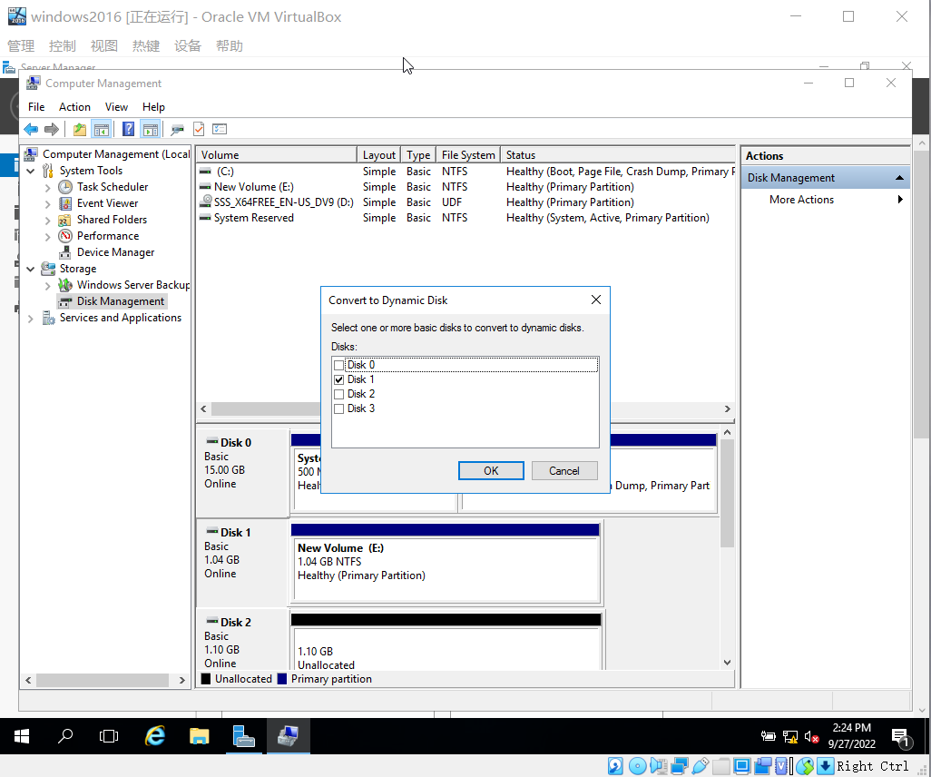

Figure 3.4 Convert to Dynamic Disk dialog box.

1. Verify the disk or disks to convert in the Disks to Convert dialog box and click Convert.
2. Click Yes in the Disk Management information box.
3. If necessary, click Yes to acknowledge that the file systems on the disk will be dismounted.
4. Notice under the Type column that the basic disk has now been converted to a dynamic disk.
5. Delete all of the dynamic disk volumes on the disk, using the Disk Management tool, by right-clicking the volume, such as (D:), and clicking Delete Volume. Then click Yes in the Delete simple volume dialog box and click Yes again.

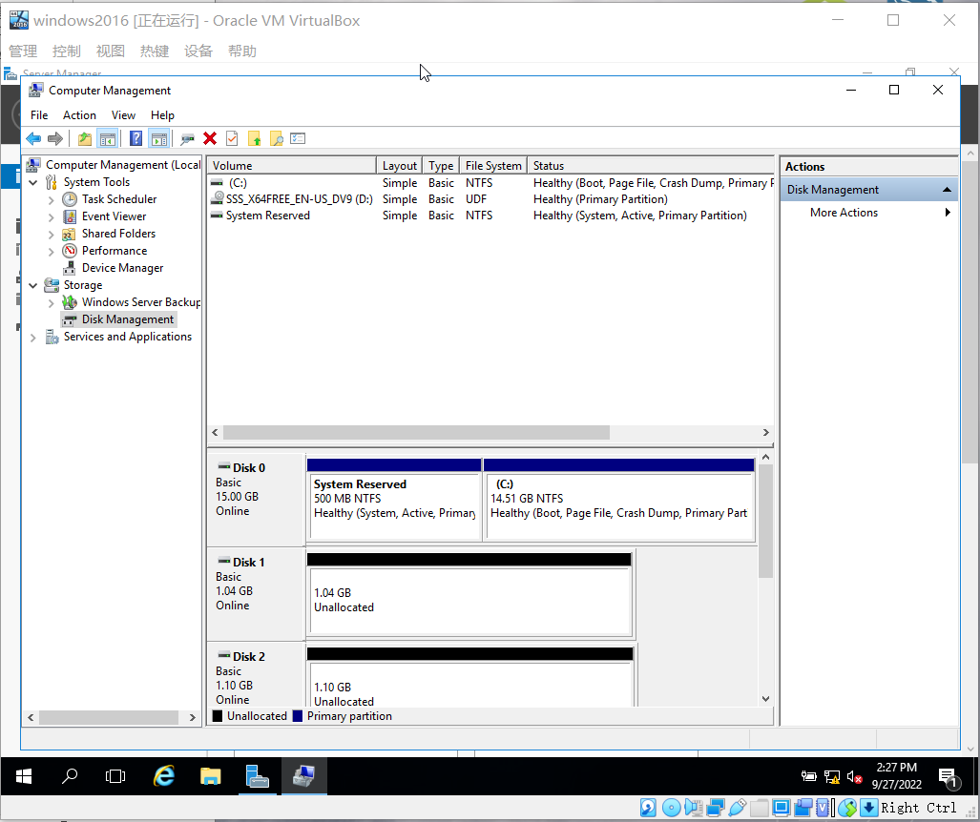Figure 3.5 Delete All of the Dynamic Disk Volumes on the Disk.

1. The disk should convert back to a basic disk automatically.

# Activity 5-4 Installing the Windows Server Backup Tool and Backup a Folder

**Time Required**: Approximately 10 minutes

**Objective**: Install the Windows Server Backup tool.

**Description**: Performing regular backups is a critical task for ensuring your organization’s working environment. Even if you lose a disk drive or inadvertently delete an important folder, you still have your important information if you have it backed up. You probably won’t need to restore from backups often, but when you need to, there is no better feeling than having sound backups. In this activity, you install the Windows Server Backup tool that some server administrators prefer using for backups, because it is native to Windows Server.

**Requirements**: Take screenshots on Step 7, 11, 13, 15, 17, 19, and 25.

1. Open Server Manager, if it isn’t already open.
2. Click Manage and then click Add Roles and Features.
3. If you see the Before you begin window, click Next.
4. In the Select installation type window, ensure that Role-based or feature–based installation is selected and click Next.
5. Make sure your server is selected in the Select destination server window and click Next.
6. Click Next in the Select server roles window.
7. Click the box for Windows Server Backup in the Select features window. Click Next.

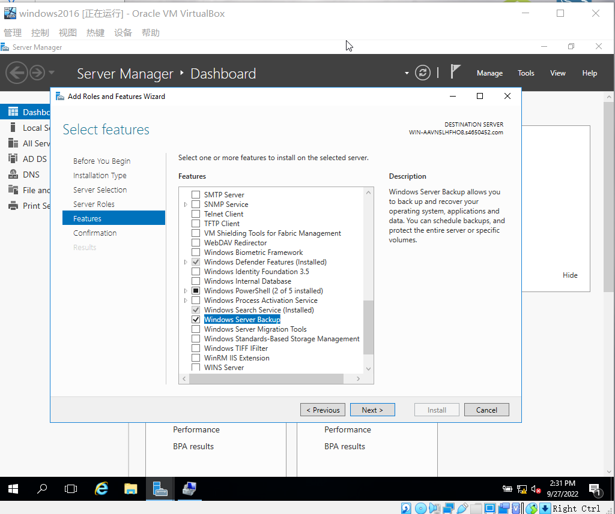

Figure 4.1 Click the box for Windows Server Backup

1. In the Confirm installation selections window, click Install.
2. In the Installation progress window, make sure the installation succeeded and then click Close.
3. Click File Explorer.
4. Create a folder, named MountGL. Create a file, named Test_Backup, inside the folder.

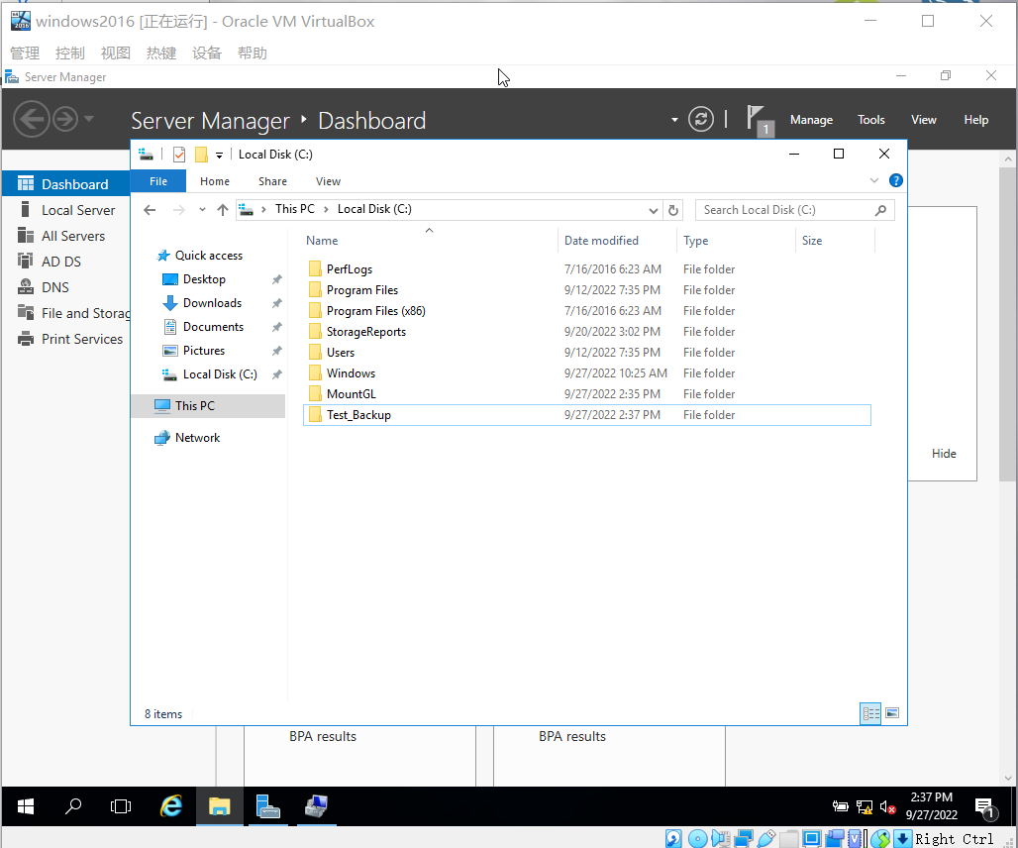

Figure 4.2 Create a folder.

1. Create a new volume using Step 1– 8 in Activity 5-3.
2. Click Tools and click Windows Server Backup.

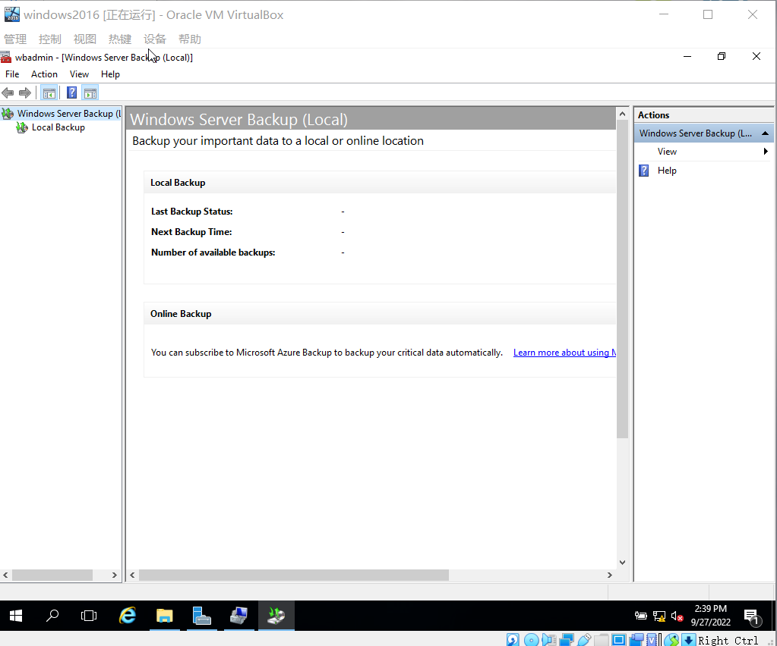

Figure 4.3 Open Windows Server Backup.

1. In the left pane, click Local Backup, if it is not selected. Wait a moment, if necessary for the tool to read your files.
2. Click Action in the menu bar in the top left portion of the window and click Backup Once.

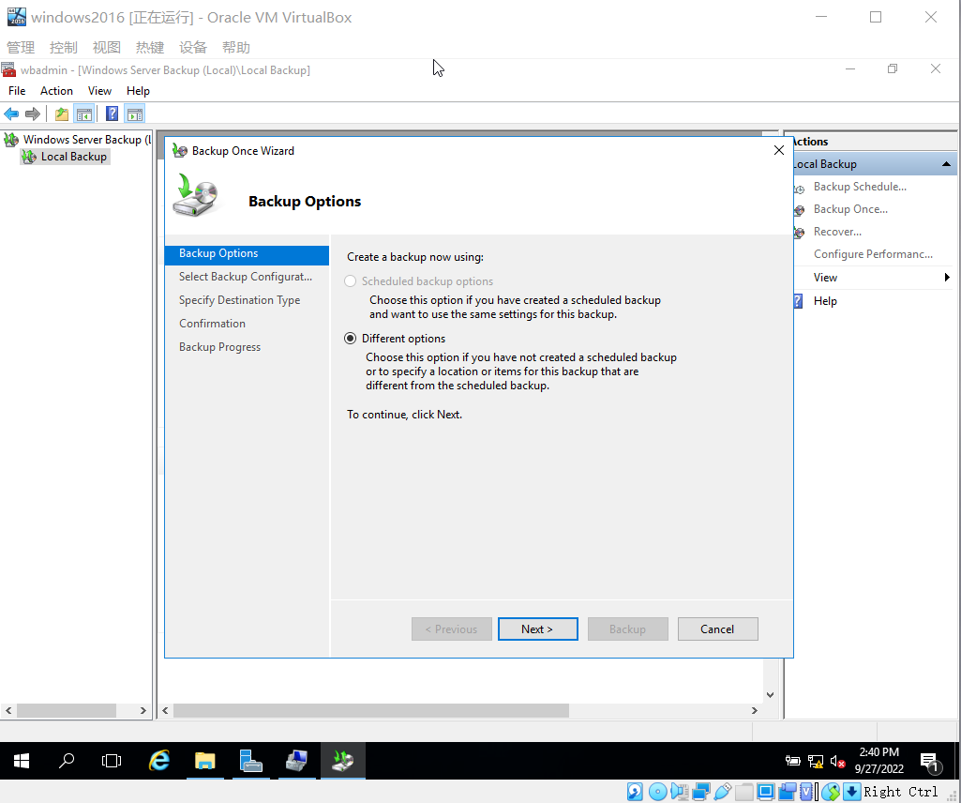

Figure 4.4 Click Action and click Backup Once.

1. In the Backup Options window, Different options should be selected by default. Click Next.
2. In the Select Backup Configuration window, notice that you can do a Full server backup or a Custom backup. Select Custom and click Next.

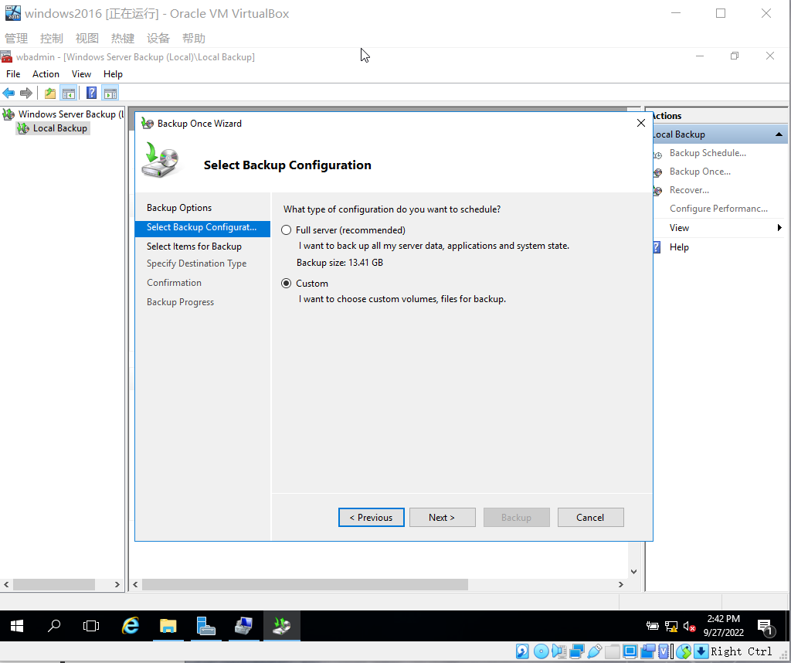

Figure 4.5 Select Custom and click Next.

1. In the Select Items for Backup window, click Add Items.
2. In the Select Items window, click the plus sign in front of Local disk (C:), making sure you do not place a checkmark in its box at this time.

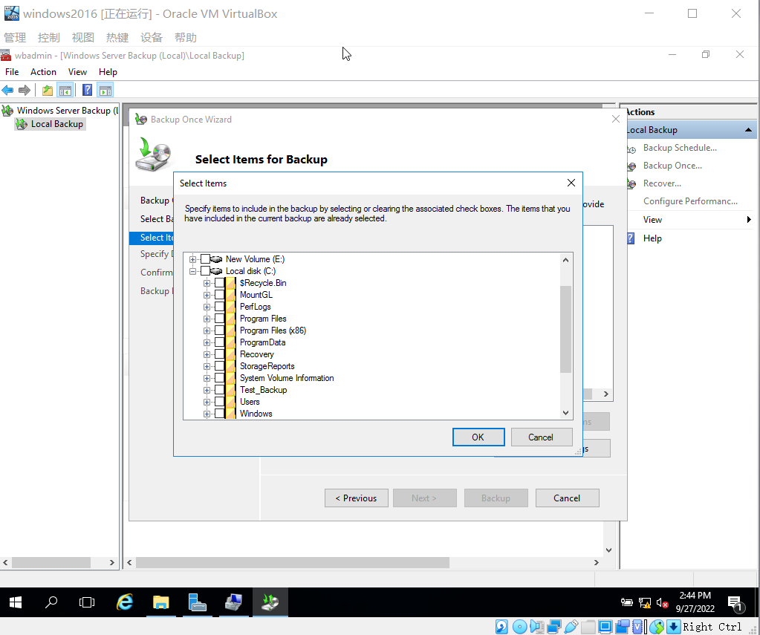

Figure 4.6 Making Sure do not Place a Checkmark in its Box .

1. In the Select Items window, Place a checkmark in the boxes for created folder MountGL under Local disk (C:). Click OK
2. In the Select Items for Backup window, click Advanced Settings. Notice that you can configure settings for a VSS backup. Click Cancel.
3. Click Next in the Select Items for Backup window.
4. Ensure Local drives is selected in the Specify Destination Type window. Click Next.
5. In the Select Backup Destination window, leave the default backup destination and click Next.
6. In the Confirmation window, notice your selections for System state are listed. Click Backup. Then waiting backup complete. Click Close

. Record Backup Progress.

. Record Local Backup panel.

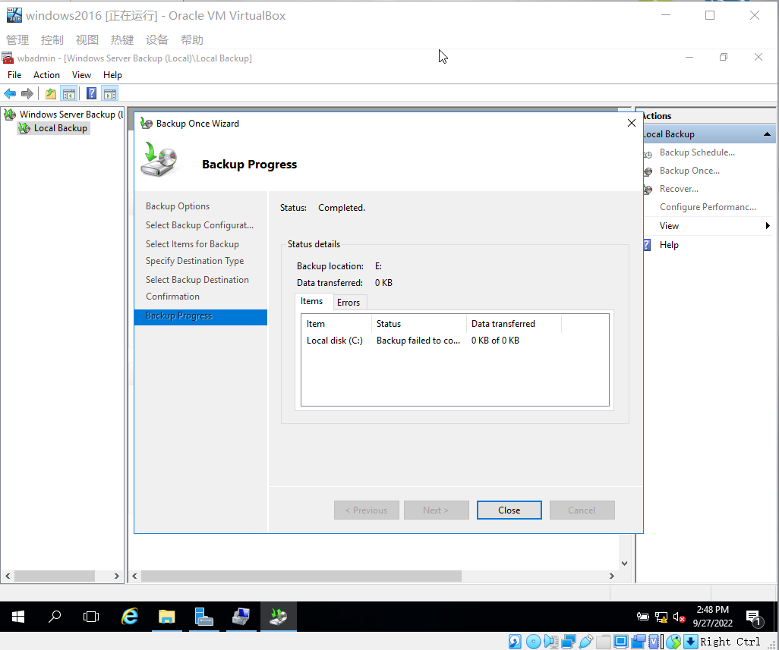

Figure 4.7 Click Backup. Then waiting backup Complete.